UNITING CHURCH IN AUSTRALIA

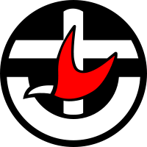

Canberra Region Presbytery
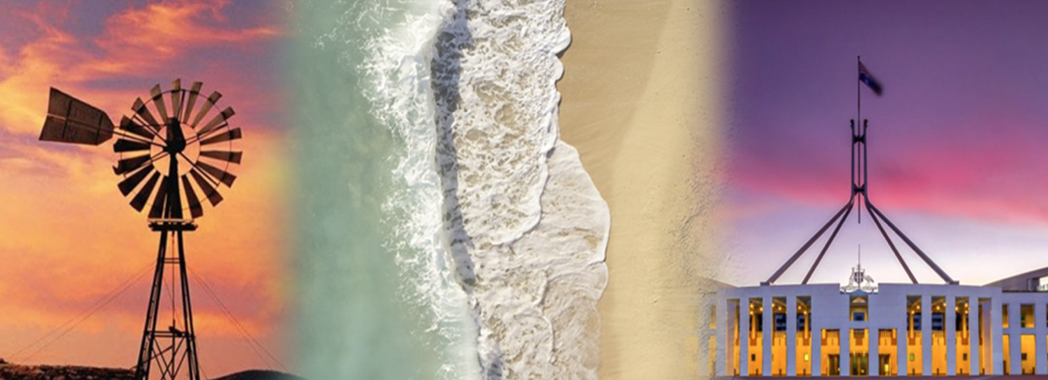

The Induction Service of
Country, Coast and Capital

Rev. Myung Hwa Park

as

Minister of the Word
Woden Valley Uniting Church

Saturday 15 August 2026, 2 pm

